Conditional Random Fields
Conditional Random Fields (CRFs) are widely used in NLP for Part-of-Speech (POS) tagging where each word in a sentence is assigned a grammatical label such as noun, verb or adjective.
As probabilistic sequence-labeling models, CRFs capture contextual and dependency relationships between neighboring words and tags, allowing more accurate labeling of entire sentences rather than individual words.
For the sentence: “She likes to read books”
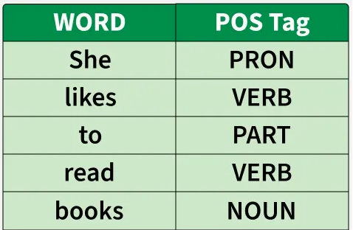

POS Tag

These tags help machines understand grammatical structure which is useful in tasks like:
- Machine Translation
- Sentiment Analysis
- Text to Speech
- Information Extraction

How CRFs Work
CRFs model the entire sequence as a single structured prediction problem and assign scores to possible tag sequences. They select the most probable global label sequence by combining feature weights and transition dependencies across the sentence. CRF Probability:

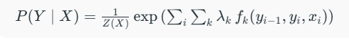

where
- XX: input words
- YY: output tags
- fk()fk​(): feature functions
- λkλk​: learned weights
- Z(X)Z(X): normalization factor

Types of Conditional Random Fields (CRFs)
- Linear-Chain CRF: Used for sequence labeling tasks like POS Tagging and NER by modeling tag dependencies in a chain.
- Higher-Order CRF: Captures relationships beyond immediate neighbors, allowing longer tag dependency modeling.
- Skip Chain CRF: Links distant but related words to handle long-range dependencies.
- Semi-Markov CRF: Predicts segments instead of single tokens, useful for chunking and phrase-level labeling.
- CRF with Neural Networks (Neural CRF): Combines CRF with LSTM/BERT features to improve accuracy in modern NLP tasks.

Web URL : https://www.geeksforgeeks.org/nlp/conditional-random-fields-crfs-for-pos-tagging-in-nlp/

